Date: October 16, 2026
Computer Engineering · Antonio Varas campus · Instructor: Arturo Guerra Castro
Group 2 · Exequiel Alvarado, Diana Guerrero, Manuel Jansen, Cristian Jorquera
APT Project: Alloxentric Generic Support Chatbot

Guía3. Informe final Proyecto APT
Asignatura Capstone

1. APT Project final report
El objetivo de este informe es que describas los aspectos más relevantes de tu Proyecto APT. Es importante que fundamentes las decisiones que tuviste que tomar a lo largo del proceso.

A continuación, encontrarás distintos campos que deberás completar con la información solicitada, los que dan cuenta del resumen de tu proyecto APT y sus principales resultados.

Project name | Alloxentric Generic Support Chatbot
Performance area(s) | Software solution development and data management: a multi-tenant web application with relational and vector storage, integration of external services (language model, website crawling) and cloud deployment with continuous integration.
Competencies | · Develop a software solution using techniques that systematize the development and maintenance process, ensuring the objectives are met.  · Build data models that support the organization's requirements according to a defined design that scales over time.  · Manage IT projects, offering alternatives for decision-making according to the organization's requirements.  · Perform certification tests of both products and processes using industry best practices.

Final report contents
1. APT project relevance | - Every company that offers a software product has to answer its users' questions and problems. Doing it with dedicated human support for each product is expensive and does not scale, and since each company has its own documentation, the usual answer is a custom development per client. The project solves this with a single multi-tenant platform: each company loads its knowledge and gets a support chat that answers with that information and hands over to a person when it cannot solve the request.  The situation is located in Chile, at Alloxentric, a communications automation and customer service company, and at the companies that hire its services: WellQ, Alloxentric, Directa and Dani27001 as initial clients, and Duoc UC as a real test case with its full website. It impacts those companies' end users, who get an immediate answer in their language, and their support teams, who receive only the cases the bot cannot solve, with the conversation context.  It is relevant to Computer Engineering because it brings together what the job market demands today: cloud web applications, data models with isolation between clients, integration of language models with an organization's own data (RAG) and automated tests that certify behavior. The value added is a first line of support that is not built twice and does not make things up: what it says comes from the company's knowledge base.
2. Objectives | - General objective: develop, verify and put into production a multi-tenant conversational support platform for Alloxentric, with an administration module, a web chat with technical and sales agents based on RAG, and a console for the people who receive handed-over conversations.  Specific objectives and status as of October 16, 2026:  1. Build a multi-tenant administration module in Spanish, English and Portuguese, with light and dark mode. Achieved: two levels (platform and company), creation, editing, deactivation and reactivation of companies.  2. Implement an ingestion pipeline that processes documents, FAQs and the website, and builds a knowledge base per company and per chat type. Achieved: includes batched crawling with per-company rules and editable pages.  3. Develop the RAG conversational engine with two specialized agents and an intent classifier. Achieved: 7-step LangGraph graph with verification and data check; replaceable OpenAI-compatible provider.  4. Enable the support channels. Achieved for the web (single link and widget); WhatsApp out of scope (ADR 0002).  5. Implement handover to a person through live chat or ticket and an agent console. Achieved locally; in the Vercel deployment live chat is limited (no WebSocket).  6. Verify quality and isolation with automated tests. Achieved: 391 tests in continuous integration; the annotated question bank and the confusion matrix are in progress.
3. Methodology | - Scrum adapted to a four-person team was used, with two-week sprints planned in Jira over epics, user stories and subtasks (191 issues across three sprints). Each story is implemented on a branch and reaches main through a pull request carrying its key, reviewed and with green continuous integration: ruff, 391 tests on SQLite, the suite on PostgreSQL with pgvector and the frontend build. Quality assurance is part of the flow: Cristian writes the tests for each story and findings are fixed in their own pull requests. Architecture decisions are recorded as ADRs.  The methodology was appropriate because the project changed base midway (on August 28 the built system was received): short sprints allowed re-planning without losing what was done, and continuous integration provided the safety net to modify a system the team had not written. The story → pull request → test traceability makes it possible to show what was done and that it works.
4. Development | - 1. Definition and planning (weeks 1 to 4): team setup, Git and Jira, meeting with Alloxentric, backlog and planning presentation.  2. Base change and verification (from August 28): reception of the built system, audit of the code against the client's document, continuous integration and fixing linter warnings.  3. Data and deployment (weeks 5 to 8): multi-tenant model and migrations, Supabase with pgvector, deployment of the frontend and API on Vercel (ADR 0001) and demo data for the four companies.  4. Functionality (weeks 7 to 10): knowledge base as CRUD, website crawling with per-company rules, company administration, end-user account, handover to a person and QA tests per story.  5. Conversational engine (weeks 7 to 11): from a LangChain chain to a LangGraph graph with rephrasing, classification, search, generation, verification, business rules and data check; replaceable provider with fallback.  6. Answer quality (weeks 10 and 11): calibrated relevance threshold, exact per-company search and a test with a large real website (Duoc UC: 172 pages and 987 per-semester curriculum documents).  Pending for closing: annotated question bank and confusion matrix, decision on live chat in production, demo video and user manual.
5. Evidence | - The evidence is in the Phase 2 › Project Evidence folder of the repository:  · Project presentation (pptx): scope and limitations, release plan by user stories and deployment diagram, in 11 slides, plus 6 appendix slides for questions (Duoc UC load times, how the bot answers, a live demo script, screenshots, measurements and known limits).  · Documentation evidence: project and backend READMEs, closed scope, ADR 0001 and 0002, engine and search documents, Jira backlog, list of pull requests, continuous integration runs and the report of the 391 tests.  · Evidencias de sistema Aplicación Base de datos (system, application and database evidence): in Aplicación, screenshots of the application in production (home page, platform and company panels, knowledge base, agents, Duoc UC and Directa chats, agent console, English and dark mode, mobile); in Base de datos, SQL schema, data dictionary, entity-relationship model and list of migrations.  They account for the development because they show the process (stories, pull requests, tests) and the result in operation (production).  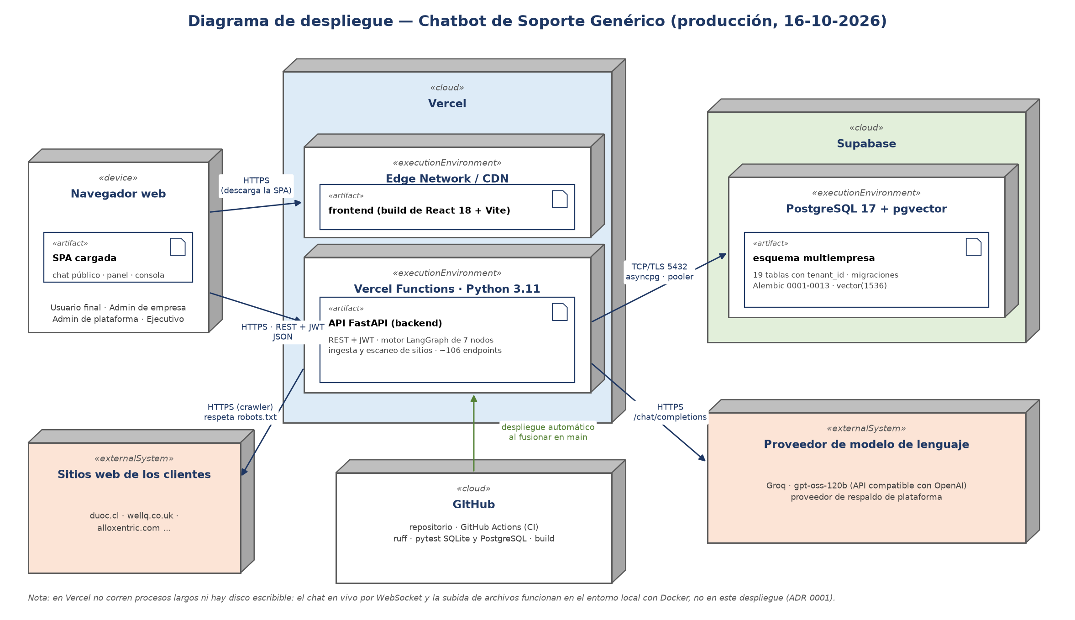  Deployment diagram  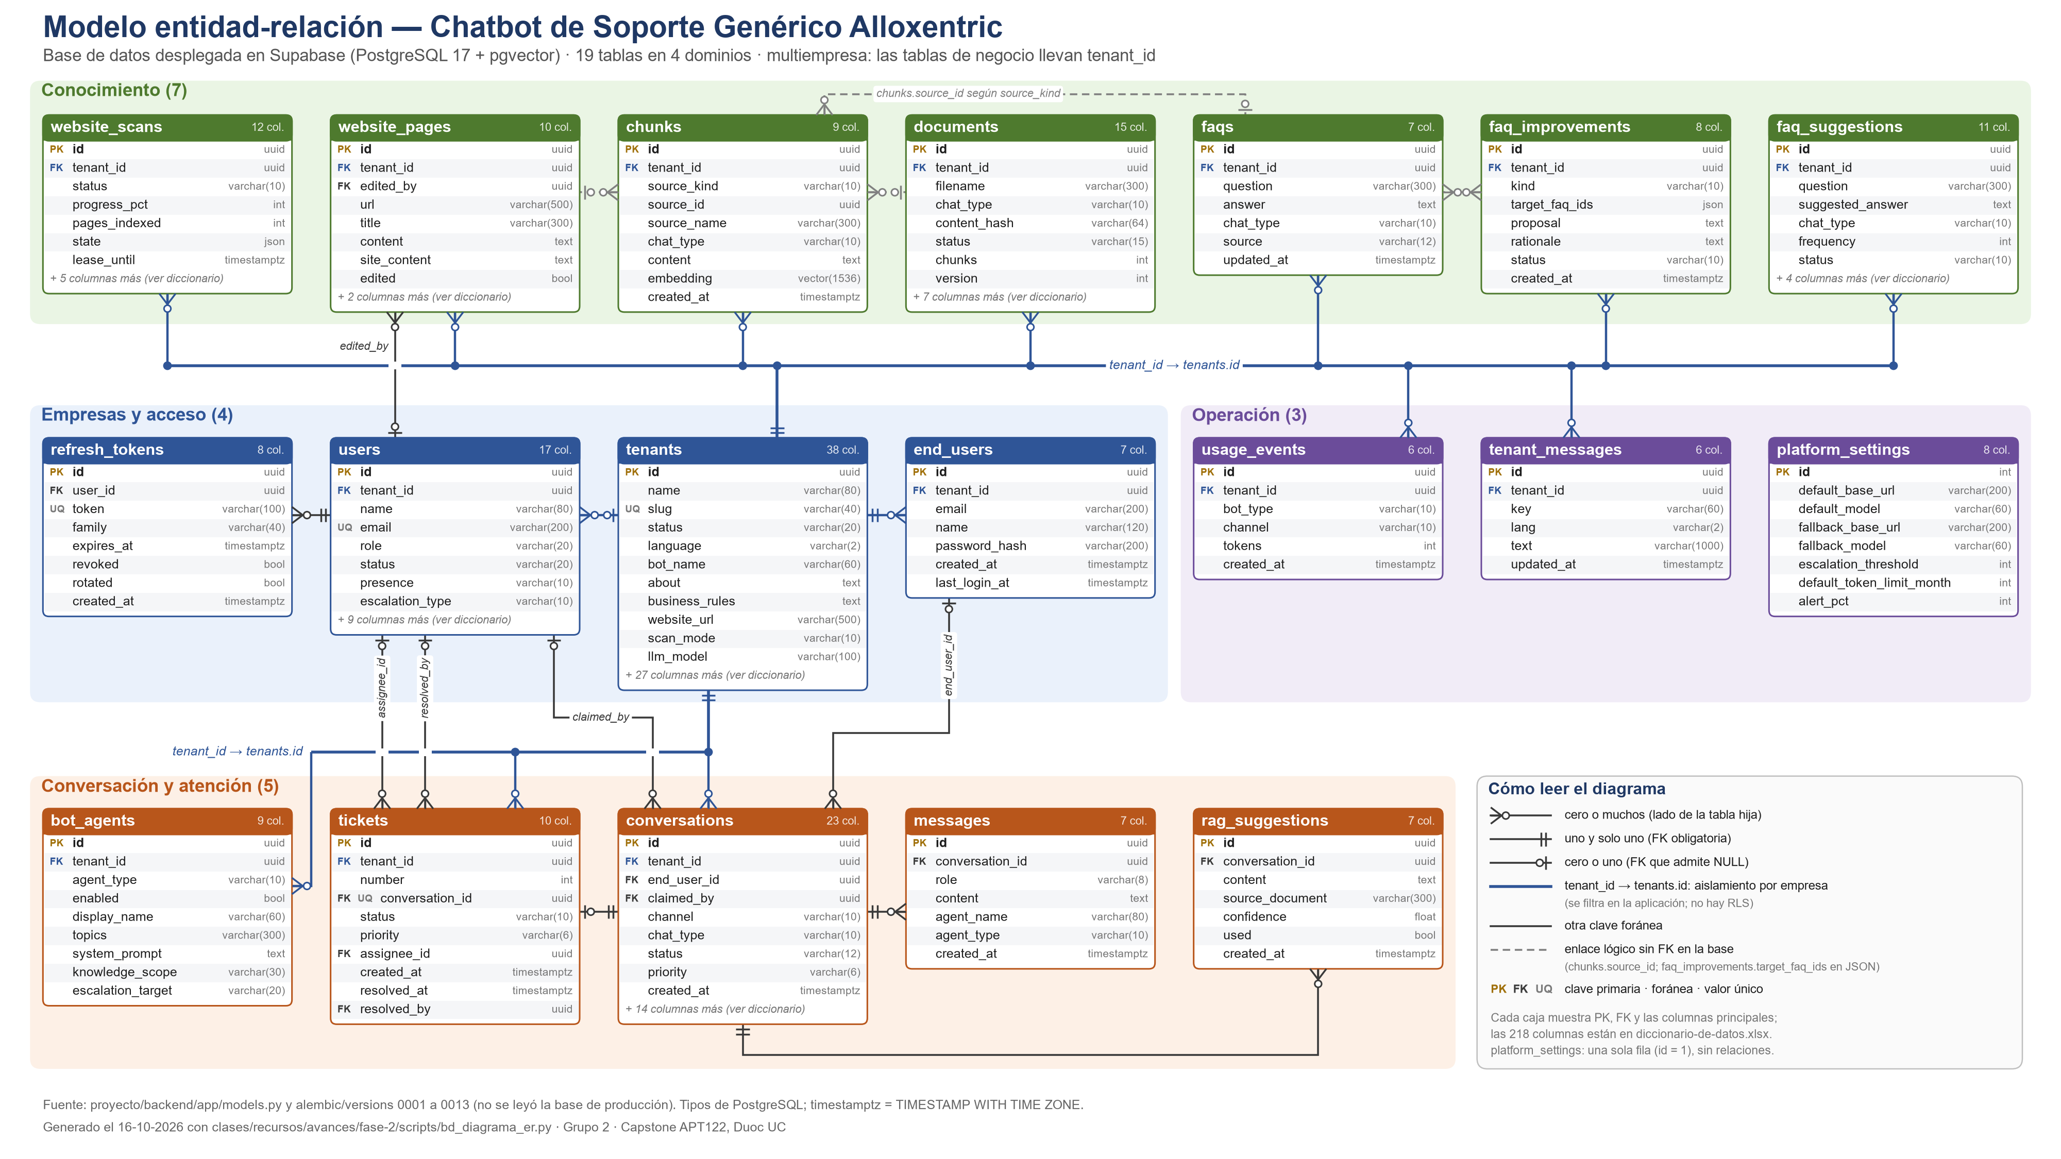  Entity-relationship model
6. Professional interests and outlook | - The project connected with each member's interests. Exequiel sought backend development, multi-tenant architectures and language models over an organization's own data, and the project took him to real production decisions: vector search that skips results, verification that cannot depend on the provider and deployment with concrete limits. Diana sees her career in project and product management, and the Jira backlog gave her practice in turning a client document into prioritized stories. Manuel is interested in interface design and data modeling, and worked at both ends: mockups and the database connection. Cristian aims at quality assurance, and wrote the tests that found real defects before they reached production.  Looking ahead, the team comes out with experience in a kind of system many companies demand today: assistants that answer with an organization's own documentation, with quality control and traceability.

